Transcription Menu
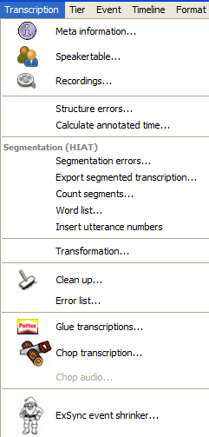

Transcription > Meta information…
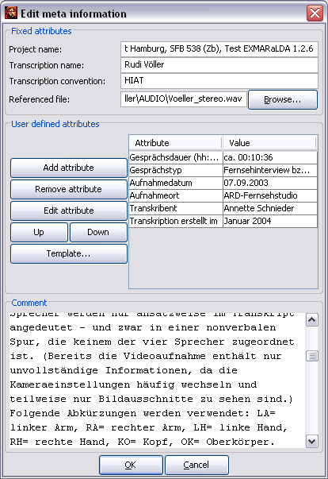

Opens a dialog in which the transcription's meta information can be saved and edited, i.e. information about the transcriber, the recordings, the conventions etc. The meta information is organized into a set of attribute-value pairs. Some of them are predefined:
Project Name: the name of the project.
Transcription: the name of the transcription. For HTML or RTF output, this name is used as the document name.
Transcription Convention: the transcription convention made use of.
Referenced File: the associated digitized audio or video file, if available. The "Browse..." button next to this field opens a dialog with which this file can be located and assigned.
Comment: allows comments on the recording and transcription.

In addition, an unlimited number of user-defined attributes can be added. To add a new user-defined attribute, click Add attribute. A new attribute-value pair is added to the table. It can be edited in the corresponding text fields.

Double clicking marks the content of a field in the table and allows the overwriting of the content. Conclude your input with Enter.

If the space under “Value“ does not suffice, click the button with the three dots (...) in order to get a larger window in which you can edit.

In order to delete a user-defined attribute, select it in the table and click Remove attribute.

In order to make use of a user-defined attribute from a different transcription, click Template and browse for the transcription in the file dialog that appears.

To change the order in which the attributes are listed, select the attribute you would like to move and click Up or Down.

In order to save the changes made in the meta information, close the dialog by clicking OK .

Transcription > Speakertable…
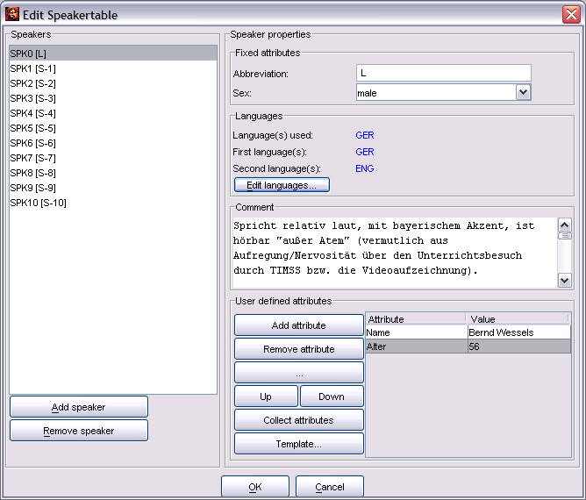

Opens a dialog for the input and editing of information on the speakers. In the upper section of the speakertable the speakers are listed. In order to add a new speaker click Add speaker. In order to delete an existing speaker from the list, select the corresponding entry in the list and click Remove speaker.

In order to add or change the information corresponding to a speaker, first select the speaker from the list. Under „Speaker properties“ the already existing information is displayed. The speakertable consists of attribute-value pairs. Some of them are predefined:
Abbreviation: the speaker abbreviation that is also used for the tier labels. (when activating the option "Auto“, see "Tier > Edit Tier properties“)
Sex: the sex of the speaker.
Languages: the first (L1) and second (L2) languages of the speaker, as well as the languages the speaker uses in the transcription („Languages used“).
Comment:allows comments on the speaker.

In order to change the entries under "Languages“ click Edit languages... . The following dialog will appear:

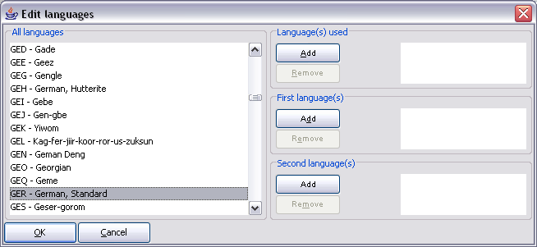

To assign a language to a speaker, select it from the list on the left side. Then click the corresponding Add-button. In order to delete a language, select it in the table on the right and click the corresponding Remove button. (Please note: The languages codes available in the list have adopted from "Ethnologue“ (http://www.ethnologue.com/). Look up the website should you require more information on this list.

In addition, an unlimited number of user-defined attributes can be added for the speakers. To add a new user-defined attribute, click Add attribute. A new attribute-value pair is added to the table. It can be edited in the corresponding text fields-

Double clicking marks the content of a field in the table and allows the overwriting of the content. Conclude your input with Enter.

If the space under „Value“ does not suffice, click the button with the three dots (...) in order to get a larger window in which you can edit.

In order to delete a user-defined attribute, select it in the table and click Remove attribute.

In order to apply all the already defined attributes for the current speaker to other speakers in the transcription, click Collect attributes.

In order to make use of a user-defined attribute from a different transcription, click Template and browse for the transcription in the file dialog that appears.

To change the order in which the attributes are listed, select the attribute you would like to move and click Up or Down.

In order to save the changes made in the speaker table, close the dialog by clicking OK.

Transcription > Recordings…
Opens a dialog through which digital audio and/or video filescan be linked to the transcription.

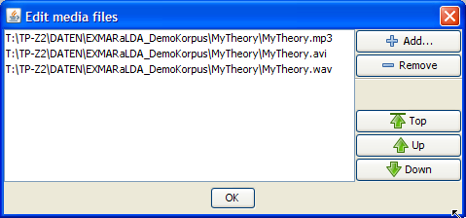

Use the "Add..." button to add a media file to the list. Select an entry in the list and click "Remove" to delete that entry from the list. Select an entry in the list and use the buttons "Top", "Up" and "Down" to change the order of the files. Please note the following:

- For the oscillogram view, the editor will search for a file with the file extension "wav" or "WAV". If the editor finds such a file, the oscillogram will be calculated on the basis of this file. If the editor does not find one, a timeline without an oscillogram is drawn on the basis of the first file in the list.
- The player always loads the first file in the list. If you load a different media file with help of the Audio/Video Panel, it will be placed at the top of the list.
- The "HTML Partitur + Flash Player" output (see File > Output...) searches for the first file with the extension "mp3" or"MP3". If no such file is found, the corresponding error message will appear.
- Normally, files in the list should only be distinguishable on the basis of their file format (Audio vs. Video, different Codecs). In particular, they should all be of the same length.

Transcription > Structure errors…
Displays a dialog for editing structural errors (see also the document How to edit and correct transcriptions).

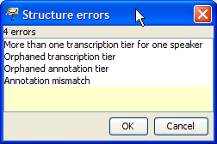

The following structural errors can occur:
- "Temporal anomaly": absolute time values in the time axis have to show a monotonous increase.
- "More than one transcription tier for one speaker": there may only be one tier of type "T"(ranscription)" for every speaker.
- "Orphaned transcription tier": Tiers of type "T(ranscription) have to be assigned to a speaker.
- "Orphaned annotation tier": Tiers of type "A(nnotation)" have to be assigned to a speaker. Furthermore, in addition to this tier there has to be a tier of type "T(ranscription)" that is assigned to the same speaker.
- "Annotation mismatch": for every event in a tier of type "A(nnotation)" there has to be an event or a chain of interrelated events in the associated tier of type "T(ranscription)" which has/have the same start and end point.

Double click an element in the list in order to get to the section in the transcription where the error occurred.

Transcription > Calculate annotated time…
Calculates the total duration for the existing events in every tier

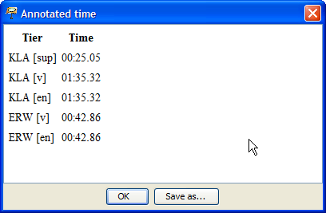

Transcription > Segmentation errors…
Opens a dialog with all segmentation errors of the current transcription. The segmentation algorithm set under "Edit > Preferences > Segmentation" is taken as a basis.

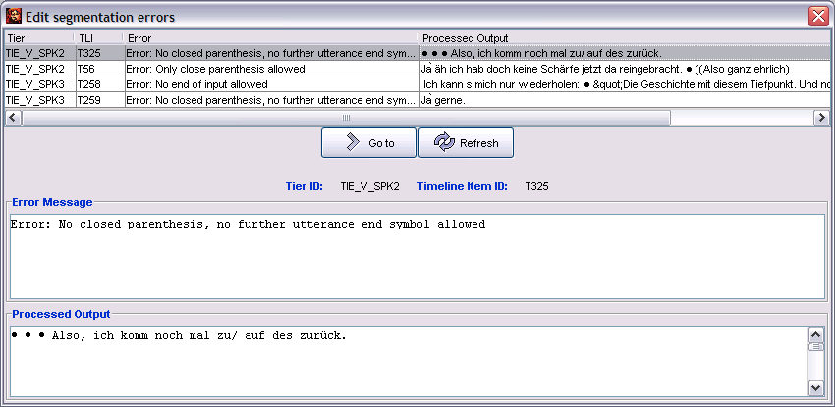

In the table in the upper half of the dialog, all segmentation errors are listed that resulted from the segmentation of the entire transcription For every error the following information is noted in four columns:

Tier: the tier, in which the segmentation error occurred.
TLI: the time point on the axis at which the segmentation error occurred.
Error: the cause of the error.
Processed output: the output that has been processed up to the occurrence of the error.

If an entry is selected in the table, the content of the corresponding column is shown in the text field in the lower part of the dialog. This can be especially useful for longer error messages or longer processed output.

In order to mend the segmentation errors, do the following:

- Select the errors you would like to edit by clicking on the corresponding column in the table.
- Click Go to to move the musical score to the position where the error occurred.
- Correct the error. The dialog can remain open.
- Click Refresh to have the remaining segmentation errors displayed.
- Should segmentation errors remain, repeat from step 1.
- Close the dialog by clicking onto the x in the top right corner.

Transcription > Export Segmented Transcription…
Applies the segmentation algorithm set under "Edit > Preferences > Segmentation" to the transcription that is currently opened. If the segmentation runs successfully a dialog that allows saving the transcription is pops up. Note that the segmented transcription can not be read by the Partitur-Editor. Their purpose is the integration into a EXMARaLDA corpus and are used for the work with EXAKT, for example. Thus, during this process, you shouldn't overwrite the existing basic transcription, but give the segmented transcription a new name.
If the segmentation fails, the following dialog will appear:

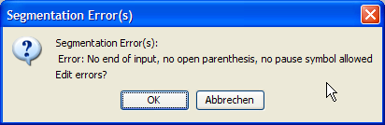

Click "OK" to have the dialog for editing segmentation errors displayed (see Transcription > Segmentation Errors...").

Transcription > Count Segments…
Applies the segmentation algorithm set under "Edit > Preferences > Segmentation" to the transcription that is currently opened. If the segmentation is successful, a dialog will appear that enumerates??? various units of the transcription in a table (the type of units are defined by the segmentation algorithm).

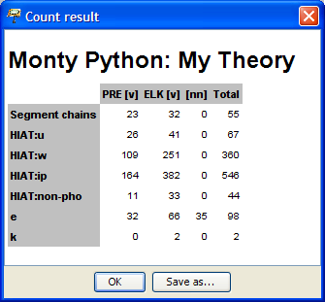

If the segmentation fails, the following dialog will appear:

Click "OK" to have the dialog for editing segmentation errors displayed (see Transcription > Segmentation Errors...").

Transcription > Word list…
Applies the segmentation algorithm set under "Edit > Preferences > Segmentation" to the transcription that is currently opened. If the segmentation is successful, a dialog will appear that shows all units segmented as words in a list.

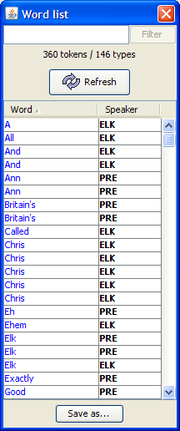

Click the table heading "Word" or "Speaker" to sort the list alphabetically by words or speakers. The button "Save as..." allows you to save the word list as an HTML file. You have two options:

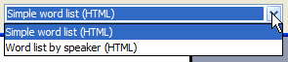

"Simple word list (HTML)" saves the word list as a simple alphabetically sorted word list. "Word list by speaker (HTML)" first sorts the word list by speakers and then alphabetically.

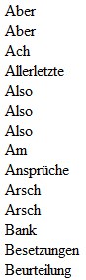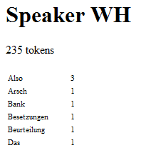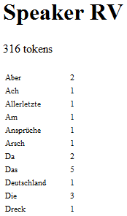

Transcription > Insert Utterance Numbers
(This function will only be shown if HIAT has been set as Preferred Segmentation:Edit > Preferences > Segmentation HIAT)

Adds an annotation tier of the category 'no' for every speaker in which utterances are numbered in a temporal order, as compliant with the HIAT segmentation, e.g.:

Before:
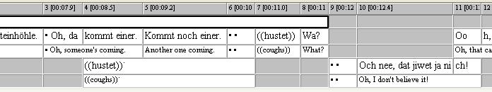

After:
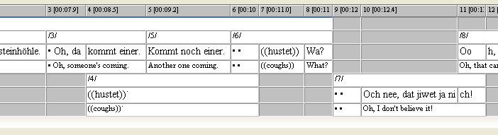
The requirement is that, first, the transcription can be segmented according to HIAT. Should this not be the case, an error message will appear that addresses the segmentation error.

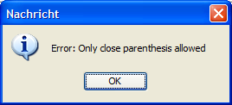

In this case, check and correct the segmentation errors with the function Transcription > Segmentation errors...
Secondly, every utterance boundary has to coincide with an event boundary. Should this not be the case, as in the following example ...

... the following error message will appear:

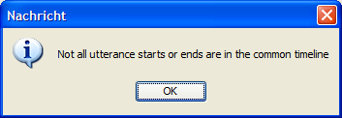

In this case, split the affected event into two at its utterance boundaries.

Transcription > Transformation…
Opens a dialog which allows flexible transformation of a transcription into different formats.

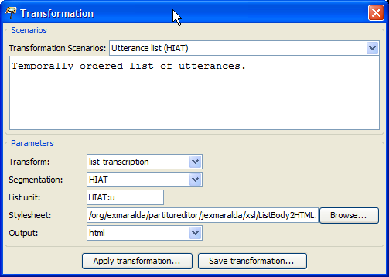

The following parameters can be set:

Transform: What should be transformed? The basic transcription (i.e. the transcription that is edited in the editor), a segmented transcription (i.e. a version of the basic transcription onto which a segmentation algorithm has been applied), or a list transcription (i.e. a segmented transcription in which units have been sorted into lists?
Segmentation: Which segmentation algorithm should be used? This parameter is only necessary if a segmented or a list transcription has been selected under "Transform".
List unit: Which unit is the basis of the list? This parameter is only necessary if a list transcription has been selected under "Transform".
Stylesheet: Which (XSL) stylesheet should be applied to the transcription? If you leave the field blank o stylesheet will be used and the output will be in XML. Suitable stylesheets can be found on the EXMARaLDA website under "Download"
Output: Which file type should the output be? You can choose between HTML, XML, TXT and "other"

Various transformation scenarios are available. These make use of stylesheets that are integrated in the code (EXMARaLDA.jar).

Transcription > Clean up...
Opens a dialog that offers options for the automatic clean up of the transcription.

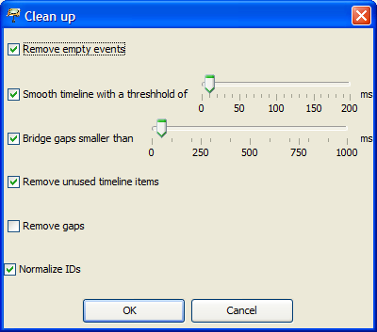

Remove empty events: activate this option if you would like to remove empty events from all tiers that is, events that do not contain text.
Smooth timeline with a threshold of: Activate this option if you would like to combine timeline entries that lie very close together. With the help of a threshold you can define which entries are to be considered as "lying close together".
Bridge gaps smaller than: activate this option if you've provided timeline entries with absolute time values and would like to close the gaps in the time axis that are smaller than the predefined value in milliseconds. To set this value, move the scroll bar to the desired value.
Remove unused timeline items: is equivalent to the menu item „Timeline > Remove unused timeline items“ (s. u.).
Remove gaps: is equivalent to the menu item "Timeline > Remove gaps“ (see below).
Normalize IDs: ensures that IDs for time points, tiers, speakers etc. are assigned consistently.

Transcription > Glue transcriptions...
Glues a second transcription to the end of the currently opened transcription.

First, you are asked to select a file to be glued. Thereafter, a dialog will appear with which you can define the assignment of tiers in the current transcription („Transcription 1“) and the transcription you intend to glue ("Transcription 2“). The tiers that have been assigned to each other are shown in the right text field ("Mappings“).

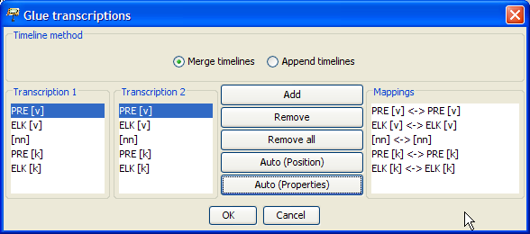

To assign the tiers individually ("by hand"), use the following functions:
Add: To carry out an individual assignment, select both of the entries in the left text fields and click Add to add this pair to the right text field.
Remove: In order to undo an assignment, select the entry in question in the right text field and click Remove.
Remove all: In order to delete all assignments, click Remove all.

There are two ways to assign the tiers automatically:
Auto (Position): Assigns the tiers according to their position, hence the first tier in transcription 1 will be assigned to the first tier in transcription 2. the second tier in transcription 1 will be assigned to the second tier in transcription 2 etc.
Auto (Properties): Assigns the tiers according to their properties, hence tiers with the same speaker abbreviation and the same category are assigned to each other.

It is possible to combine both manual and automatic assignment with each other.

"Timeline Method" allows you to choose whether time points should be sorted according to their absolute time values when they are being glued,("Merge timelines", is recommended for fully aligned transcriptions) or whether the two time axes should simply be stringed together.("Append timelines").

Once you've completed the assignment of the files click OK to glue the transcriptions.

Transcription > Chop transcription…
Divides the entire transcription into various partial transcriptions while keeping the original file.

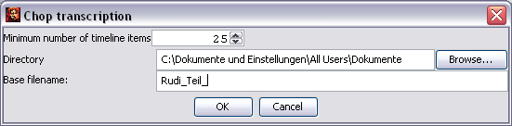

Minimum number of timeline items: The minimum number of timeline intervals per partial transcription is set so that the original transcription is divided into ten partial transcriptions. (In this example the original transcription had a timeline consisting of 252 intervals.) You can change the value with the arrow keys o the right of the number at will.
Directory: click Browse…, to select a directory in which the new partial transcription should be saved.
Base filename: Then enter a base filename for the files that are then automatically numbered consecutively.

Close your input by clicking OK. A separate window will inform you of the successful production of the partial transcriptions.

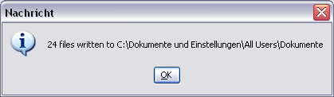

Now the directory you previously selected will contain a set of new xml files that each represent a section of the original transcription.

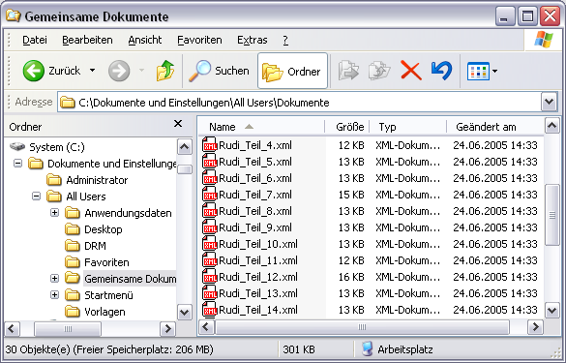

Transcription > Chop audio…
Divides a copy of the audio file of the musical score into a number of smaller audio files ("audio snippets").

Please note that the use of this function requires

- that you've assigned an audio file to the musical score via "Referenced media file“,
- that the audio file is in .wav format file (other audio formats can not be processed) and
- that the time axis has as many absolute time values as possible.

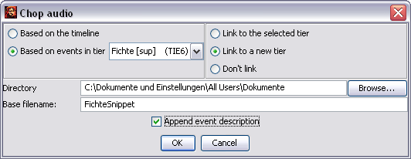

There are two ways to chop the audio file:
Based on the timeline: The audio file is chopped in accordance with the time axis. An "audio snippet" is created for every interval of the time axis.
Based on events in tier: The audio file is chopped in accordance with the events in the selected tier: For every event an "audio snippet" is created.
Furthermore you have the option of linking the newly created "audio-snippets" with the musical score in the same step:
Link to the selected tier: The created "audio snippets" are linked to the currently selected tier automatically.
Link to a new tier: The Partitur-Editor automatically generates an additional tier in which the "audio snippets" are linked to the musical score.
Don’t link: The "audio snippets" are only generated without being linked to the musical score.

In the lower section of the dialog you will then be asked to enter a name and a location where you would like to save the file.
Directory: Is the directory on your computer where you would like to save the the newly created audio files. In order to change the directory click Browse… .
Base filename: Is the base filename for the files that are to be created.
Append event description: The first symbol of the associated text will be added to the filename of the "audio snippets" that are to be created.

The chopping may take a few seconds. Upon completion a dialog will inform you whether the chopping has been successful or whether errors occurred.

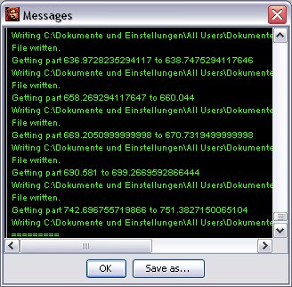

In the following example the audio file is divided in two ways and linked to an additional tier: In the "Timeline“ tier, the audio file was chopped with the option "Based on the timeline“), in the "Tier“ tier, the audio file was only chopped based on the tear of the speaker "Fichte“. The assigned "audio snippets can only be played directly from the musical score.

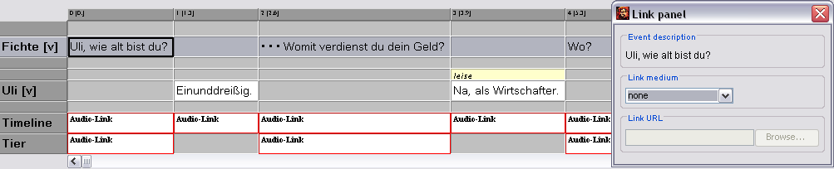

The newly generated files are saved in the previously defined directory. A consecutive number and the first symbol of the associated event were automatically added to the previously chosen Base filename:

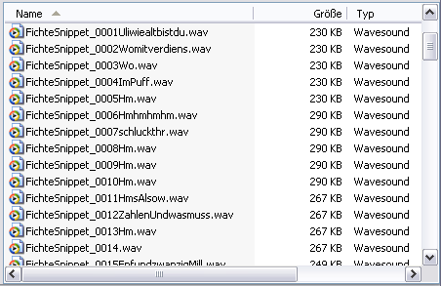

Transcription > ExSync Event Shrinker
Shrinks the events automatically after the import of ExSync-documents in accordance to their typographic expansion.(see Leitfaden für die Konvertierung von Legacy-Daten: „Importieren von syncWRITER-Daten“???).

